
ISO 8000 Master Data Quality Manager Workshop
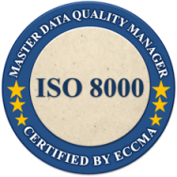
Travaasa Resort– Lone Star Room
Austin, Texas
Tuesday, October 22, 2013

REGISTRATION FORM

    FAMILY NAME (Last name): 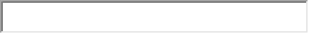

FIRST NAME: COMPANY:
ADDRESS:
CITY: STATE: 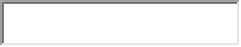 POSTAL CODE: 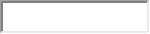
COUNTRY: 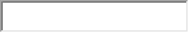PHONE: EMAIL:

WORKSHOP FEE |  | Price
 |  | $88
 |  | $175
 |  | $298
 |  | $350
 | TOTAL WORKSHOP: | $ 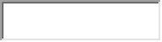

ADDITIONAL: ISO 8000 MDQM™ (INDIVIDUAL) CERTIFICATE* |  | Price
 |  | $50
 |  | $100
 |  | $170
 |  | $200
 | TOTAL MDQM CERT: | $
 | GRAND TOTAL | $
*Note: The certificate is additional to the workshop fee. Once the workshop has concluded, attendees who have chosen to receive a certificate will be able to access an online quiz. Upon successful completion of the quiz, attendees will be certified as an ISO 8000 Master Data Quality Manager and will receive their certificate. The certificate is renewed yearly by completing a quiz.

Timeline: Tues 8am - 9am Breakfast & Registration
9am - 12pm Workshop
12pm - 1pm Lunch
1pm - 3pm Workshop & Certification

PAYMENT

Payable to ECCMA, checks must be in U.S. dollars drawn on a U.S. bank


A $25.00 wire fee will be included in the TOTAL AMOUNT. ECCMA will provide bank information.


Card number: Expiry date: 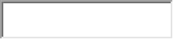

Cardholder’s name: Signature: 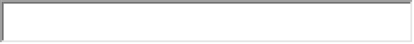

Billing Details (if different from above)
Address:
City: 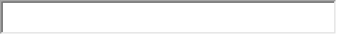 State: Zip Code/Postal Code: 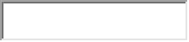
Country: Phone: 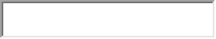 Email:

Cancellation Policy
Registration refunds less a $100 processing fee per registrant will be granted to cancellations received in writing by 9/27/2013. No refunds will be granted after 9/27/2013. Substitution for a paid registered attendee may be made at any time.

Submit Registration Form to:
ECCMA
2980 Linden St, Suite E2, Bethlehem, PA 18017 USA
Fax: +1 610 625 4657 email: vicky.falcone@eccma.org

Questions?
Contact: Vicky Falcone
Phone: +1 610 861 5990
Email: vicky.falcone@eccma.org

